LimaMar
EVENTS & CATERING

WEDDING COLLECTION
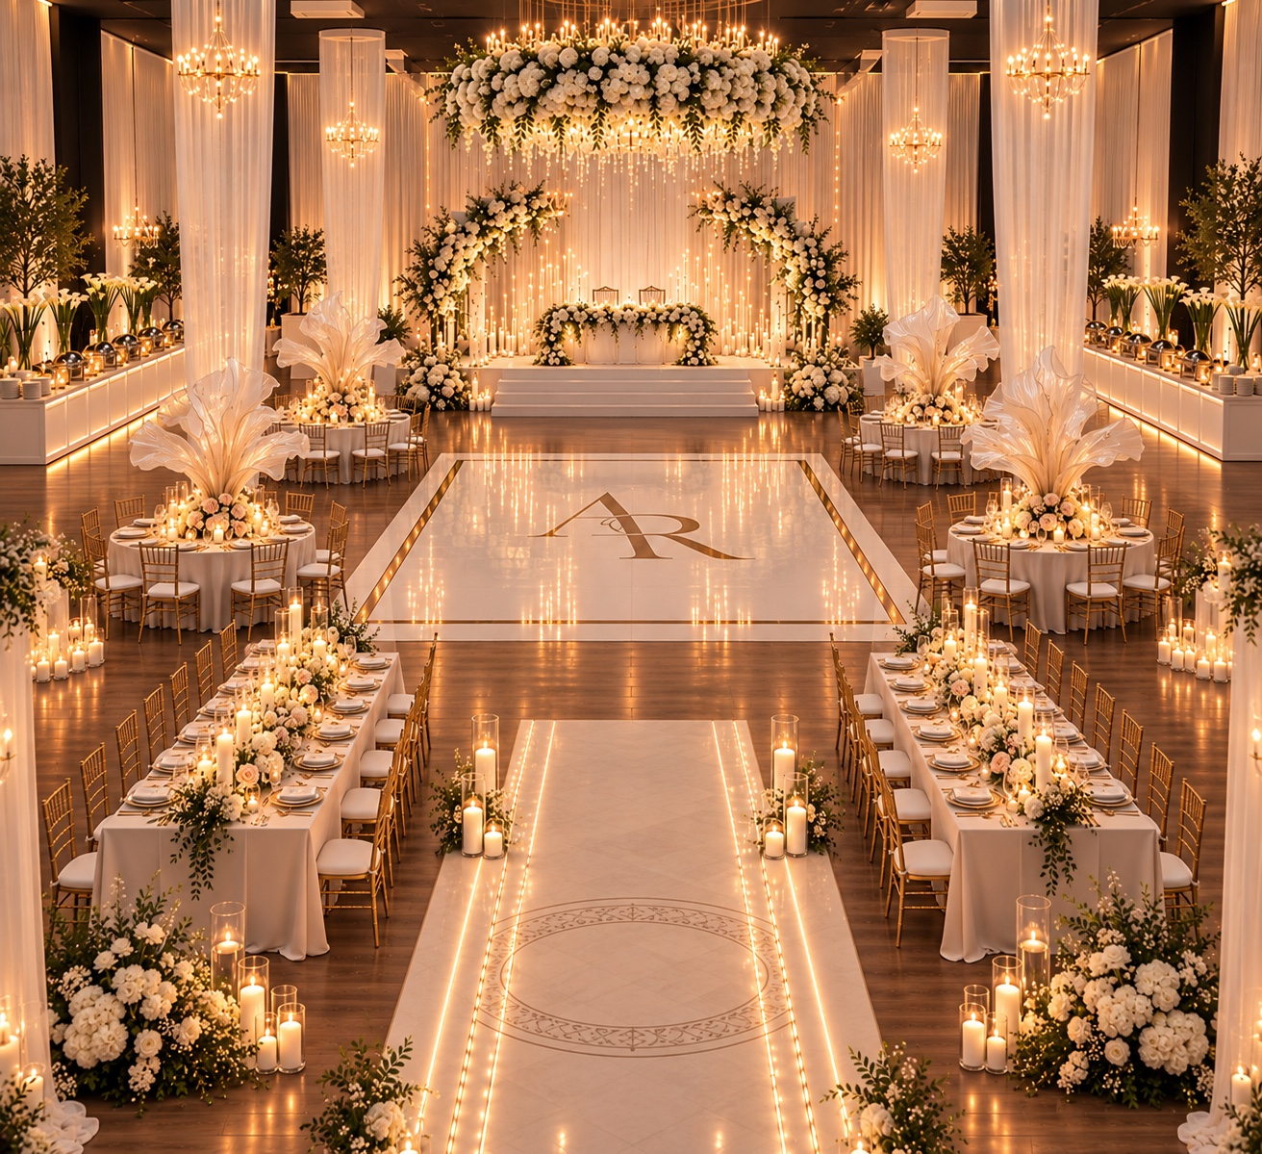
ESSENTIAL ELEGANCE • GOLDEN LUXE • ROYAL ELEGANCE
Elegant Settings | Unforgettable Moments

LimaMar | EVENTS & CATERING
PACKAGE 1

ESSENTIAL ELEGANCE
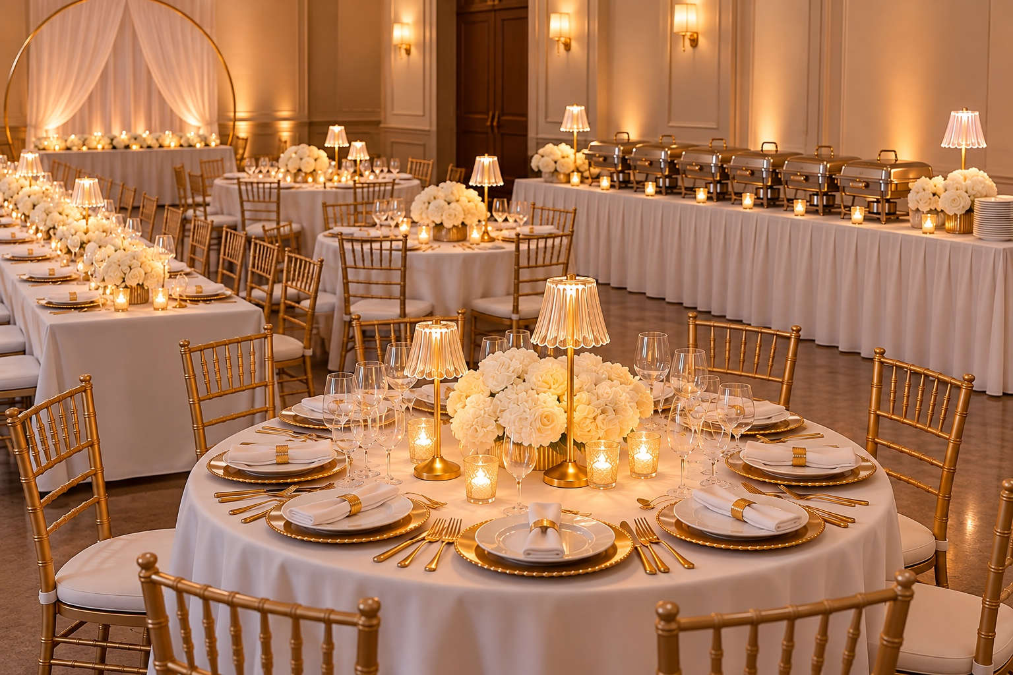
A timeless celebration with warm, classic details and an elegant atmosphere.
Official package image and final inclusions are pending confirmation. The photo shown is a temporary reference and may be replaced.

PACKAGE DETAILS
FURNITURE & TABLE LINENS
· Round and rectangular guest tables and Gold Chiavari chairs
· White tablecloths and cloth napkins
TABLE SETTINGS & BUFFET STATION
· Gold charger plates and dinner plates. Flatware and drinking glasses
· Simple white floral accents, decorative candles, and gold tabletop lamps
· Six (6) chafing dishes. Long buffet table with white tablecloth. Simple buffet presentation accents
SETUP & BREAKDOWN

PROPOSED PRICING
UP TO 50 GUESTS | 51–100 GUESTS | 101–150 GUESTS
$2,500 | $3,700 | $4,950
PRICING & PACKAGE NOTES
· Price remains the same within each guest-count tier. Final guest count determines quantities provided.
· Food, beverages, staffed catering, and applicable taxes are not included.
· Floral accents are intentionally minimal; elaborate floral arrangements and backdrop installations are not included.
· Pricing and availability are subject to confirmation before booking.

LimaMar | EVENTS & CATERING
PACKAGE 2

GOLDEN LUXE

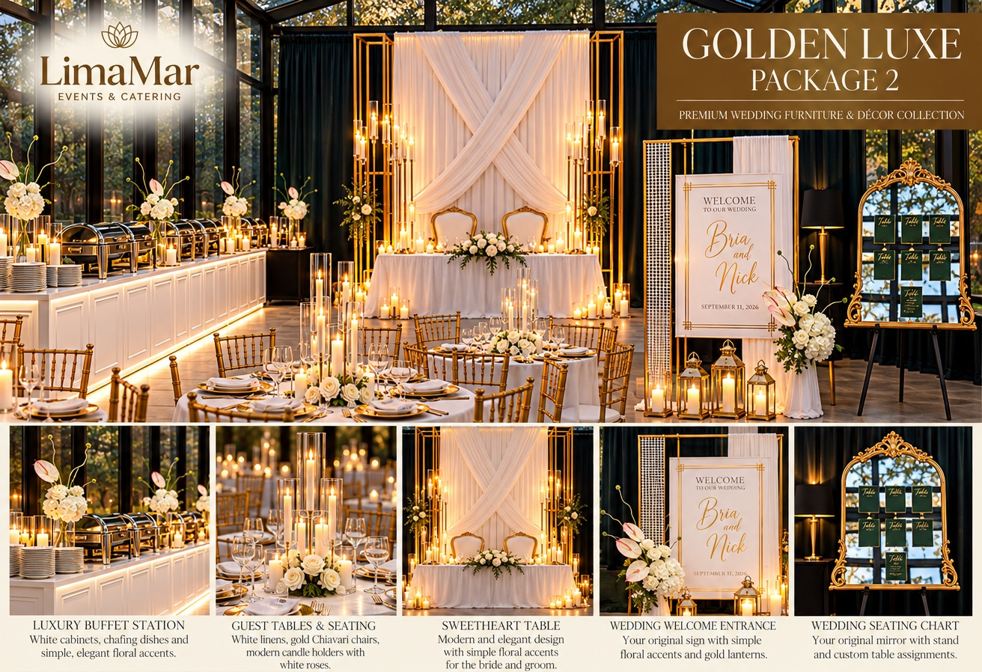
A sophisticated gold-and-ivory wedding collection with refined finishing touches.

PACKAGE INCLUDES
• Guest tables (round or rectangular) and rented gold Chiavari chairs
• Linens, napkins, chargers, plates, glassware and silverware
• White buffet cabinets and chafing dishes
• Sweetheart table with modern backdrop and decorative accents
• Wedding welcome sign and seating chart
• Delivery, setup, breakdown and pickup

PREVIOUSLY APPROVED BASE PRICING
UP TO 50 GUESTS | 51–100 GUESTS | 101–150 GUESTS
$4,500 | $6,800 | $8,900
Note: The promotional image displays different prices. Please confirm pricing before distributing.

LimaMar | EVENTS & CATERING
PACKAGE 3

ROYAL ELEGANCE
Our most luxurious wedding design concept, featuring a grand entrance and details.

PROPOSED PACKAGE INCLUSIONS
• Premium guest tables and gold Chiavari chairs
• Elevated sweetheart stage and elegant backdrop
• Entrance aisle and white-and-gold dance floor
• Buffet stations, candlelight and decorative accents
• Welcome sign, seating chart, delivery, setup and breakdown

PROPOSED PRICING — SUBJECT TO APPROVAL
UP TO 50 GUESTS | 51–100 GUESTS | 101–150 GUESTS
$6,750 | $9,750 | $12,950
Natural floral installations, suspended florals, food, beverages, DJ, and venue rental are quoted separately. Final scope and pricing require approval.

LimaMar | EVENTS & CATERING
LET’S CELEBRATE

CONTACT & INQUIRIES

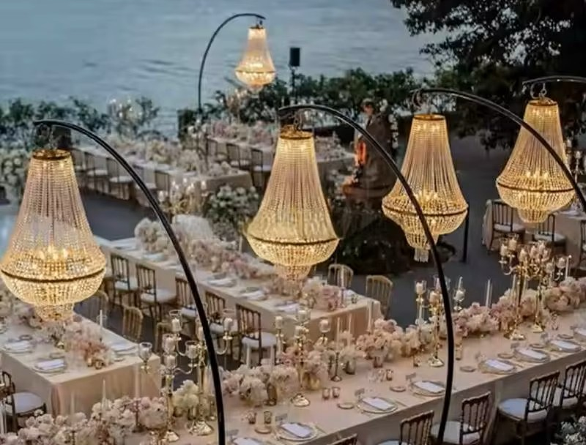

LimaMar Events & Catering
Phone: 815-566-5991
Email: limamarperu@hotmail.com
Instagram: limamarevent.catering
Facebook: LimaMarEventCatering
www.limamarestaurant.com
Contact us for a personalized wedding and event quote.

